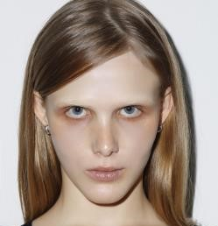
Viktoria Yerchyk
viktoriayerchyk@gmail.com
viktoriayerchyk.com
@viktoriayerchyk
Berlin-based Ukrainian dance artist & choreographer investigating how material, spatial, and social constraints shape movement as a practice of presence, necessity, and adaptive agency.

SELECTED WORKS
“Thinking Plurimi” choreographer & performer 2026
Site-specific exhibition performance responding to Emilio Vedova, Kunsthaus Dahlem (Berlin)
“Free Movement Practice” choreographer 2025 – ongoing
Exhibition performance investigating agency emerging from restriction through textile spatial structures. Research phase — seeking funding.
“Synesthesia” choreographer& performer 2022 – 2024
Movement research conducted within · DACH / Fonds DaKu (Hamburg) ·
Tanzwerkstatt Europa / Goethe-Institut (Munich) · LOORE / Nordic Culture Point (Tallinn)
“Sculptures of Intimate Spaces” movement director 2025
Performance&film choreographic study of intimacy and its cinematic reconstruction
Director: Bibiana Colmenares, Cinematography: Karim Marold

Editorials & publications performer 2023 – 2026
Vogue Ukraine · Sleek · Sicky · Glamcult · Sober · Hrishnystsya art magazine

Apache crew performer 2023 – 2024
“Kyiv” performance at La Merce festival (Barcelona) & Xjazz festival (Berlin)

Music videos&commercials performer 2019 – 2025
Directors: Elliott Power · Tanu Muino · Franka-Marlene Foth · Alan Badoev · Andzej Gavriss

EDUCATION
Berlin University of the Arts 2023 – 2024
BA Dance, Context, Choreography, guest student
Independent training through workshops&labs including 2018 – 2025
Alexander Vantournhout · Shahar Binyamini · Kenan Dinkelmann · Shay Latukolan
Kyiv school of Dance and Performing Arts 2009 – 2019
Comprehensive dance training, acting, sculpture, art history

Ukrainian · English · German

